Alfie Hippisley :

Assignment 1 Report (RPN Calculator)

Introduction:

For this assignment I was tasked with creating a program that would perform RPN calculations. The RPN calculation that was to be performed would be placed into the program via user input.

Summary of The Requirements:

The program should be able to process a complete postfix equation of tokens from a single line of user input. The answer to this postfix equation should be calculated via a stack data structure implemented via a linked list. The program should have a menu with adequate options. It should also offer guidance on how to input data into the program and how to use the program. The submission should also include adequate documentation such as a class design, Pseudo code/Activity Diagram, Test Plans , Test Sheets and a Self-Evaluation Report. There are optional requirements such as Data Validation, Invalid Postfix and the Divide Operator.

Requirements:

1:

The program should accept a complete postfix equation of tokens (Numbers and Operators) from the user as a single string.

This requirement has been fully met.

2:

The program should process the postfix equation entered and calculate a correct answer using stack data structure using via a linked list.

This requirement has been fully met.

3:

The program should include a Menu with options to show instructions on how to work the calculator and there should also be an exit option.

This requirement has been fully met.

4:

Documentation should include a class design, pseudocode or activity diagram for the primary methods. There should also be test plans for common scenarios and test sheets detailing the outcome of the tests. Also included should be a self-evaluation report.

This requirement has been fully met.

5:

The optional requirement of this assignment is to include data validation for the inputs of the program to confirm that the postfix equation is correct. This optional extra was not complete

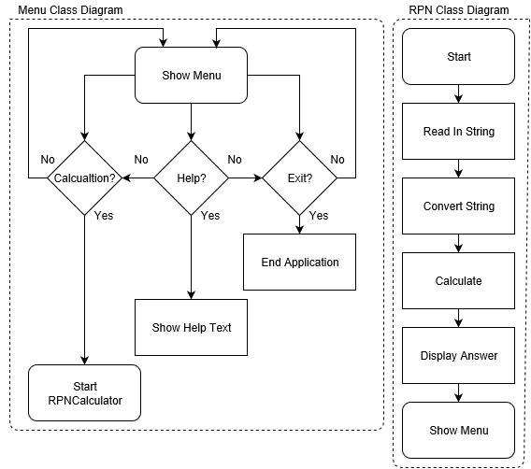

Self-Evaluation:

Overall, I think this week’s assignment went okay. I have learnt a huge amount more about Java since starting this assignment. In particular, how classes interact with each other and how linked lists and stacks work with nodes. I also learnt the hard way about time keeping as only started this assignment on Saturday and ended up spending about 9 hours on the Sunday getting it all finished up. I think if I had more time then I would have completed the optional extras.